Name: Ritika Mohan
Prn: 23070521183
Semester: 5th C (C1)
Aim: Timers and Dynamic UI (Bonus):
Use setInterval() and setTimeout() to build a countdown timer. Create a class scheduler that highlights active periods and shows alerts on start times.
Output:
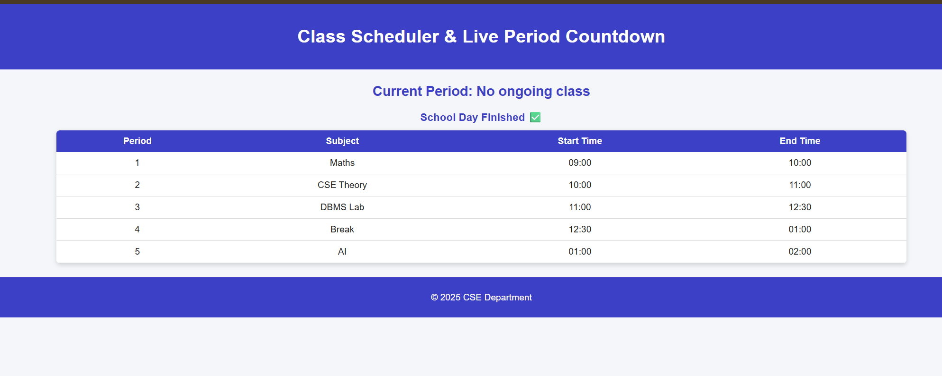
Conclusion: Created a class scheduler that highlights active periods and shows alerts on start times.

